**UCc-1 Filing**

Preparation (Before you start) make sure you have the following on hand

* Security Agreement number/s
* Payment card (credit card) details
* 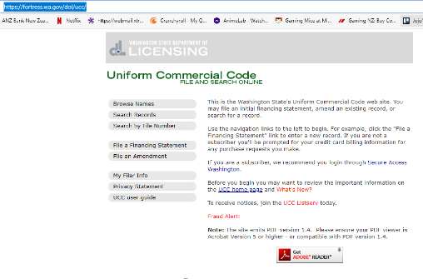Birth Certificate number

Steps

1. Go to website below

[UCC File and Search Online (wa.gov)](https://fortress.wa.gov/dol/ucc/)

1. Click on “File a Financing Statement”

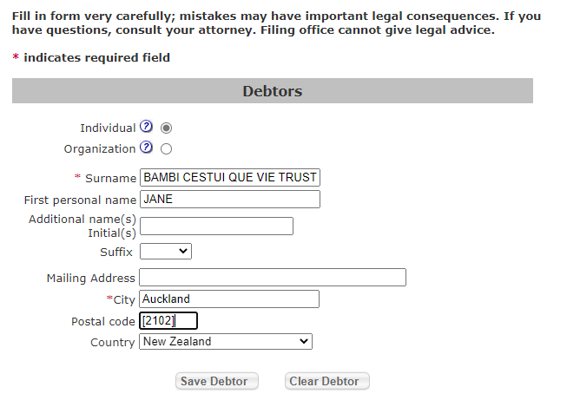

1. Complete Debtors details
2. Click “Save Debtor”

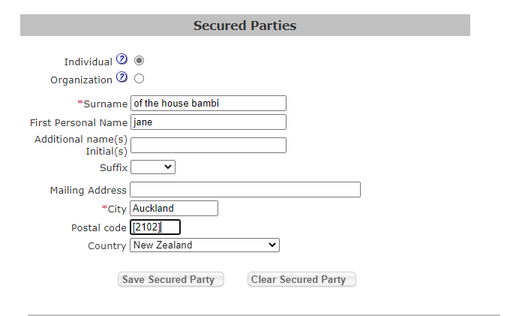

1. Complete Secured Parties
2. Click “Save Secured Party”
3. Type in the following spiel for Collateral Damage

All of debtors assets, land and personal property, and all of Debtors interests in said assets, land and property, now owned and hereafter acquired, now existing and hereafter arising, and wherever located, described fully in the security agreements SA-AOSAL-NL-11031966-001 (Take this reference number off the affidavit of status and life, then delete what is in the brackets) which states that Jane of the House of Bloggs is the preferred creditor of the debtor to the priority amount of $3,000,000,000.00 NZ as the Secured Creditor having priority above all other creditors, where the secured party also has the ability to act as the liquidator of any assets if a parent company places any of debtor's assets into liquidation without our knowledge or consent as the Secured Party, and if the parent company does not inform us as Secured Party how much the asset is worth or what it sold for then we are able to claim all costs plus full value of the asset from the parent company by providing a true bill with claim to all the value, where the parent company or the agent acting on behalf of the company has 10 working days to pay us as Secured Party in full and in the event of non-payment the parent company or acting agent of that company is then in default and we have the lawful right to seize property of the acting agent or parent company that is in default. If the acting agent or parent company refuses to inform us the value of the asset, then we as Secured Party have the right to claim the higher amount of $3,000,000,000 NZ off the parent company and seize assets up to that value in the currency of our choosing.

Inquiring parties may consult directly with the debtor ascertaining, in detail, the financial relationship and contractual obligations associated with this commercial transaction.

Identified in security agreements above, Adjustments of this filing is in accord with House Joint Resolution of June 5th 1933 and UCC1-103 and 1-104. The secured party accepts Debtors signature in accord with UCC1-201 and 3-401

Birth Certificate Number: 123456789

Debtor is a Transmitting Utility

__________________________________________

**NOTE: very important all text above has been written on US keyboard, you can change keyboard by going to bottom of screen into toolbar and change from ENG to US, if have any issues most likely to be that these symbols “, ‘, -, (, )**

1. Answer the next 5 questions by ticking where answer is “none” to all except tick that “debtor is a transmitting utility”
2. Click “File Initial Financing Statement”
3. Pay utilising your credit card. Please remember the cost is in US dollars and then print off your UCC Financing Statement
4. Print and save electronic copy of financial statement
5. When you have finished paying go back to link as above and then click on “Search by File Number” and put your file number in and search
6. It will come up with your UCC filing, click on the PDF file “Certified Search Report”. Also print this letter from Washington State Department of Licensing

And that’s your UCc 1 filing complete