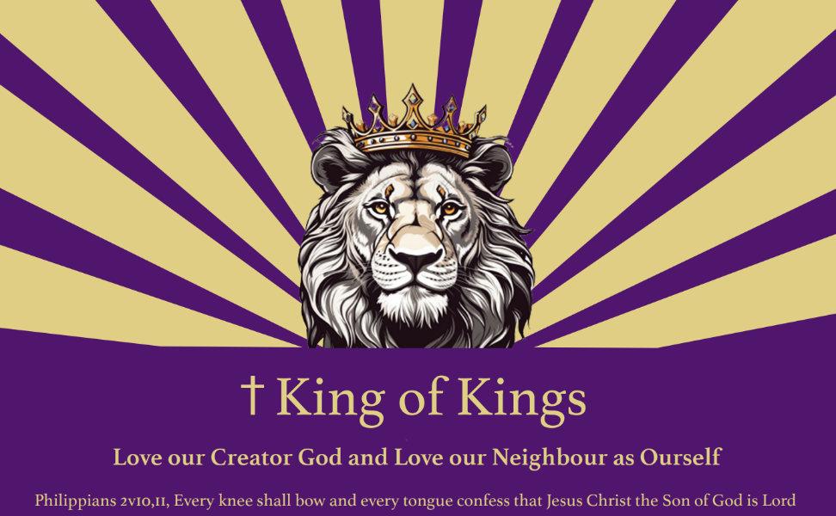

**Jurisdiction of Our land Aotearoa also known as Colony of New Zealand has returned to the authority of God Almighty**

Matthew Chapter 22 v 36-40 “Love the Lord thy God” and “Love thy neighbour as thyself.”

Note that any content or character or style or colour or page layout is not to be confused with legalese or syntax or any other language or hidden meaning. All that matters is the truth. In John Chapter 14 v 6 Jesus said “I am the way, the truth and the life.”

Proverbs Chapter 19 v 9 “A false witness will not go unpunished, and he who breathes out lies will perish.”

**LIVE LIFE CLAIM of** First and middle names **of the House of** Family name who is also known as First name of the House of Family name

**Dated:** the number day of the month of Calendar month in the year of our Lord 2024

**Genesis Chapter 2 verse 7 KJV Bible reads:**

**“**And the Lord God formed man of the dust of the ground and breathed into his nostrils the breath of life;

and man became a living soul.”

**Genesis Chapter 1 verse 26-27 KJV Bible reads:**

“And God said, let us make man in our image, after Our likeness: and let them have dominion over the fish of the sea, and the fowl of the air, and over the cattle, and over all the earth, and over every creeping thing upon the earth. So God created man in his own image, in the image of God created He him; male and female created He them.”

**Statement of Claim:**

“I, beingFirst and middle namesof the House of Family name call upon The Father, The Son and The Holy Spirit as witness to this Claim. I am the live, living claimant executor and beneficiary of my estate by the Christian nameFirst and middle names, and I affirm before The Divine Father, Lord and Creator in Heaven, that I am a live, living sentient soul, with a body of flesh and flowing blood in the form of a man/woman, of sound mind who is above the age of consent and capable of managing my own affairs, living on the land known as Aotearoa New Zealand.

**Lineal Descendant:**

“I am a live living lineal descendant of the House of Family name with the live born names being First and middle names born on thenumberday of the month of Calendar monthin the year of Our Lord in numberswithin the location of the town known as City/townin the region of Regional area on the land known as Aotearoa New Zealand.

“I, beingFirst and middle names of the House of Family name am a live living offspring to my mother being Mother’s first and middle names of the House of Mother’s family name on birth certificate and my father being Father’s first and middle names of the House of Father’s family name.

**Proof of Claim:**

“I, being First and middle names of the House of Family name do affirm that this picture and this thumbprint made with my blood of my right hand/hair sample showing DNA and this autograph are truth with this **LIVE LIFE CLAIM**.

**Picture; Hair sample: Thumbprint with own Right hand over autograph;**

I, First and middle name also declare that I am not an artificial person, I am not a corporation and that any previous consent or contract given by my hand is null and void as at the date of this **LIVE LIFE CLAIM,** and I take away the administration of any other man, woman, agent or corporation from managing my own estate and affairs where all powers of attorney have returned to me and declare that I am the only true heir and beneficiary of my estate and trust plus I am the Secured Party Creditor, not the debtor and not surety to any debt. I declare that all my debts past, present and future have been forgiven through the blood sacrifice of Jesus Christ on the Cross where Colossians Chapter 2 verses 14 and 15 from the KJV Bible declares: “14 That while I was dead in my sins, God made me alive with Christ. He forgave me all my sins having cancelled the charge of handwritten requirements that was against and condemning me; He has taken it away, nailing it to the cross; 15 And having disarmed principalities and powers, triumphing over them by the cross.” In this day I therefore declare that **Jesus Christ** has triumphed over principalities and powers by His death on the Cross and by His resurrection to life, with the confession of my faith the restoring of my soul back to life. I, First and middle names of the House of family name have the lawful right to charge those who trespass against me or my property as I declare I am a son/daughter of Almighty God redeemed by the Blood of **Jesus Christ,** and have attached my compensation schedule of fees for trespass against me or my property to my Live Life claim.

Verified by the living man/woman first and middle names of the House of Family name.

**Autograph:** Your autograph (Christian names with thumb print over your first name)

**Date:** day number day of calendar month of the year in numbers

**Matthew Chapter 18 v20 and Deuteronomy Chapter 19 v15 read:**

"A matter shall be established by two or three witnesses."

**Witnesses to this Live Life Claim:**

We place our names as witnesses with the red thumbprint of clean right hand to affirm before The Father, The Son and the Holy Spirit to hereby witness this **LIVE LIFE CLAIM** for he/she being

Jane Emily of the House of Bloggs being a live, living flesh and blood in the form of a wo/man and that he/she lives on this land known as Aotearoa New Zealand, having sufficiently identified him/herself to ourselves, in truth, by way of this **LIVE LIFE CLAIM** we affix our names in accordance and satisfaction within the relevant provisions of Divine law, Scriptural law, and Natural law.

**Witness 1: Name** John of the house of Smith. (example of how to write name)

**Autograph…………………………………………………………… sealed with my red ink Thumbprint**

**Witness 2: Name** Sarah of the house of Williams (example of how to write name)

**Autograph ………………………………………………………… sealed with my red ink Thumbprint**

**Compensation Schedule CS-initials-DOB-01 for Crown and Company Agents**

**Name and Title of person: Date and Time:**

**For any unwarranted unlawful solicited/unsolicited goods and services and/or interference in my/our private matters and/or commercial affairs or any individual interfering with my/our freedom, physical integrity, psychological wellbeing, or wilful trespass on my/our private property will be held personally liable for the following charges see UCC1-301 and UCC1-308**

1. Unauthorised use of any of my copy righted trade names: $1,000,000.00 per use
2. Accounting/book keeping/invoicing: $10,000 Per hour processing accounts and administration (min charge 4 hours)
3. Court appearance: $1,000,000 Per hour or part thereof.
4. Unlawful detention/enslavery $100,000 Per second.
5. Kidnapping/False Imprisonment $100,000 Per second.
6. Obtaining or causing loss/harm by deception $1,000,000 Per item
7. Robbery/demand with intent to steal/harm $1,000,000 Per item
8. Use physical force towards me/my property $1,000,000 Per occurrence
9. Threats of harm to me or my property $500,000 Per occurrence
10. Unlawful removal of personal property the new value of the item x 2, plus 10% added per day
11. Distress and mental anguish $1,000,000 per event and (wo)man, boy or girl
12. Extracting a signature under duress, $1,000,000 per event

to force a contract

1. Entry my property without my permission $500,000 per event and per property + per dwelling + $20,000 per metre travelled per living person plus $100,000 per photo taken plus $100,000 per second for time per living person being on my property or for any type of surveillance
2. Document preparation $10,000 Per hour/page whichever is higher
3. Meetings/Phone use/Research $10,000 Per hour
4. Automobile use $100 Per kilometre
5. Stationary $100 Per item
6. **Any type of harm or injury to me $150,000,000.00 per event**
7. **Harm or Removal of any living (wo)man or animal or plant on my land being the land of Aotearoa which encompasses the whole earth $1,000,000.00 per day/event per living item.**

**\*Fees are subject to change without notice. Fees to be charged in the currency of my choosing to the gold standard so I have the option of taking gold or asset valued to same amount.**

**Upon breach of duly delivered personal liability notice or rescinded offers to contract.**

**Notice**

Forcing or compelling a living breathing sentient being’s unpaid or voluntary performance/servitude or exercising ownership direction or control over a living soul is a criminal oﬀence that carries terms of imprisonment. Causing or forcing a living soul to enter or engage in debt bondage (involuntary forced payment) is a criminal oﬀence that carries terms of imprisonment. Slavery charges are imprisonment up to 7 years, fraud charges are from 3 to 30 years with one million dollars charge per fraudulent activity. Entry into property includes opening or entering any access way that is on my property that includes doors, windows, gates and entrance ways and any type of surveillance on or into my property.