**PPSR Personal Properties Security Register**

**Go to ppsr.govt.nz**

You will need to log in first with real me, or create a login, don’t worry too much about this step, can do this as the debtor name

**Step ONE is to secure all your property**

On the screen you will see the following headings.

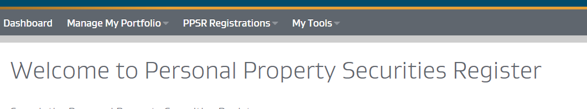

Click on manage my portfolio, then click under Secured Party Groups - Create

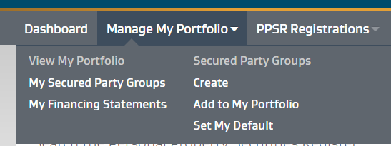

On next screen tick both boxes, then click next step

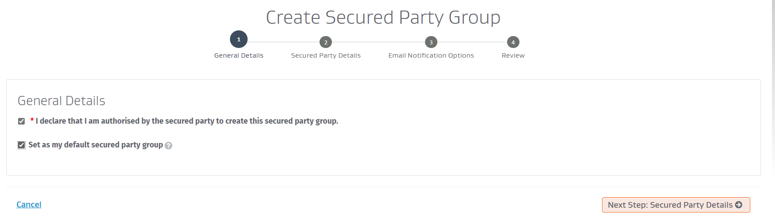

Click add Secured party, then click on person

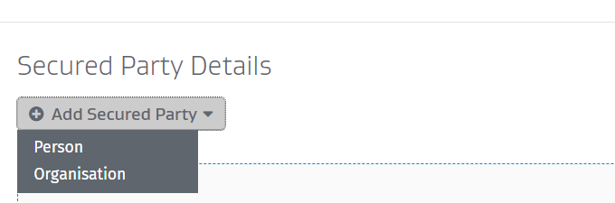

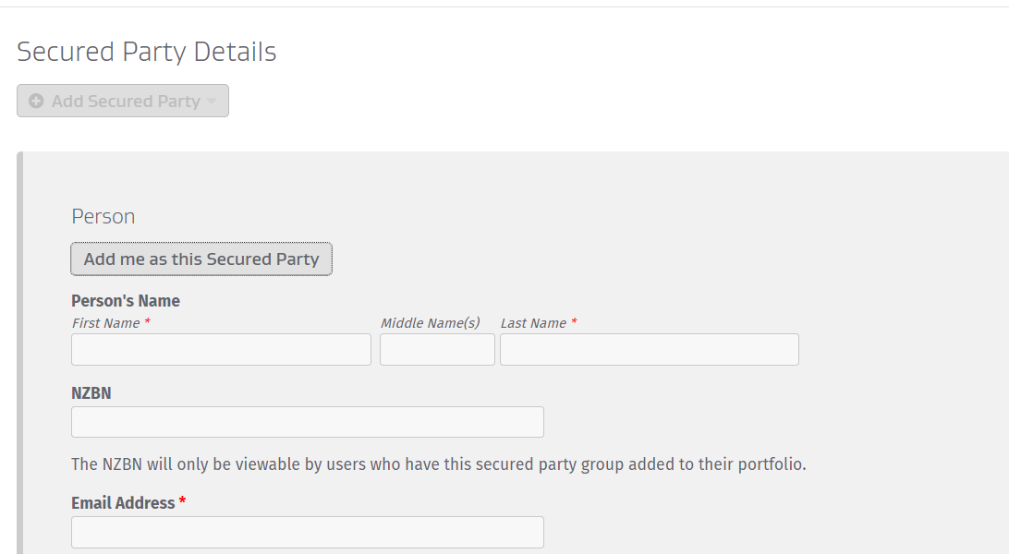

Fill out your details

For last name put … (the living do not require a surname/last name)

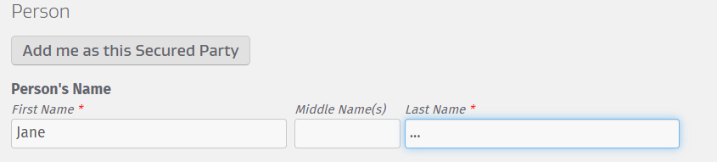

Click next, takes to page for what notifications you would like to receive by email

Tick all the boxes if you want notifications for all (recommendation)

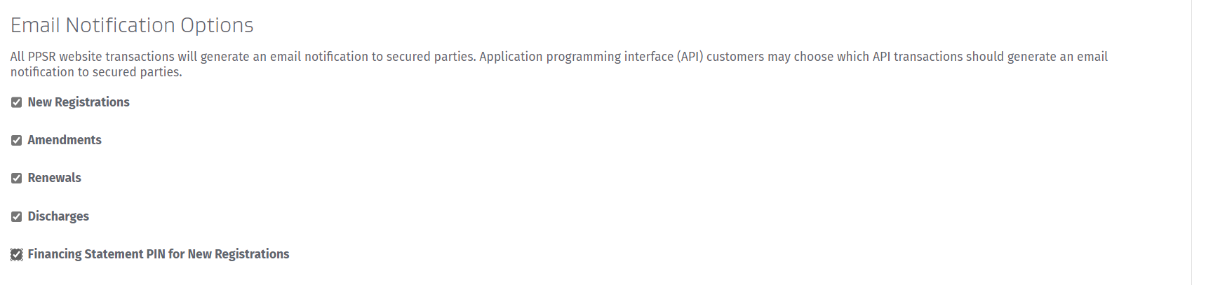

Click next, takes to review screen, check all details are correct, then click Register

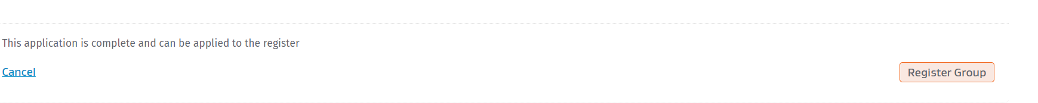

You are now set up to register financing statements.

**How to Register Finance Statement**

Log on to ppsr.govt.nz

On main dashboard screen you will see tab heading My Portfolio and under this heading you will see your secured party group, click on the ID number of your secured party group

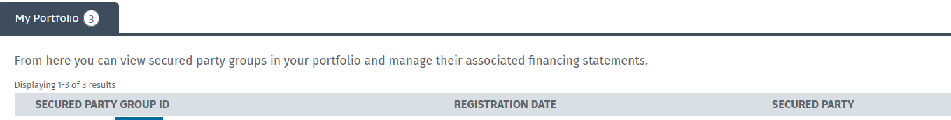

Then you will click on **create finance statement**

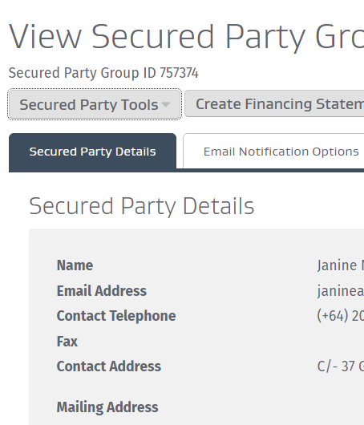

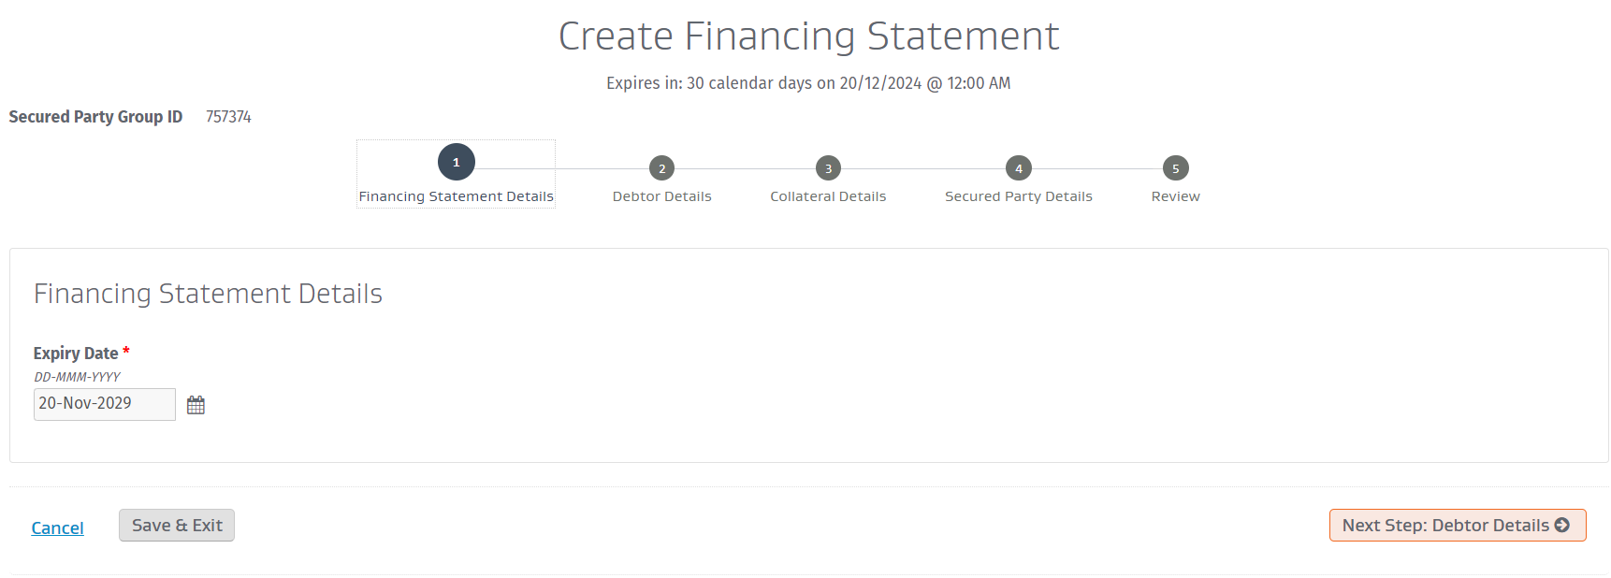

Then click next step for debtor details

You need to choose person for individual and organisation for corporation.

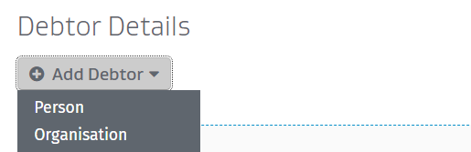

Doing a Commercial Lien Against a Corporation

You will choose organisation if doing a lien against a corporation

Here the box should be ticked for organisation look-up and you will enter the name of the corporation and as you enter the company name the details should come up as below example, if not can manually enter the company name.

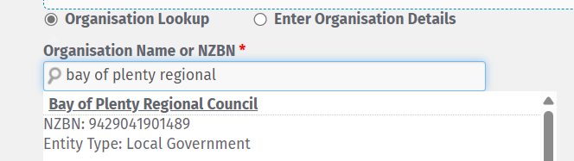

You then proceed to add the service physical address, phone number and email address.

Below these you need to choose only one- either the name of the job title, safer to choose chief executive officer in case the man/woman in the role changes as this lien is in place for 5 years

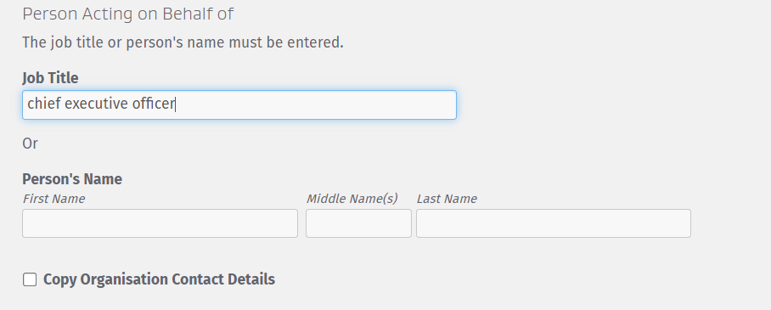

Tick above on copy organisation contact details and it will copy them into next section, click save, then next to go to add collateral details.

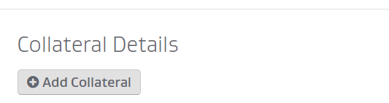

Click add collateral.

The box below is what opens up and you want to have something in every section.

**Goods:** You will not be able to add anything under motor vehicles or aircraft unless you know make and model etc, would need to give specific description of livestock and crops. Can add anything under Goods other.

To save time can copy and place this information under each of Goods, Money, Chattel Paper, Documents of Title, Intangibles, Investment Securities.

Write something in this section like this:

I, Jane of the House of Bloggs have placed a commercial lien on …………………………… Corporation for the amount of ……………………………………………………………. As the Secured Party Creditor where this debt will continue to accrue ten percent interest until this debt is settled in full, with the lawful right to add further charges of harm if harm continues and do full takeover and remove any employee who acts in a manner to cause harm to the people, the land, air, water, animals or plants or harm of any form. The lien is taken over employment contracts and related documentation, all financial and operational records, Intangibles, Negotiable Instruments, Investment Securities, All Present and After Acquired Property, Documents of Title, Chattel Paper, Money, precious metals and any owned Goods to the same value until paid out in full with the right to add ten percent penalty interest per week until this debt is settled in full.

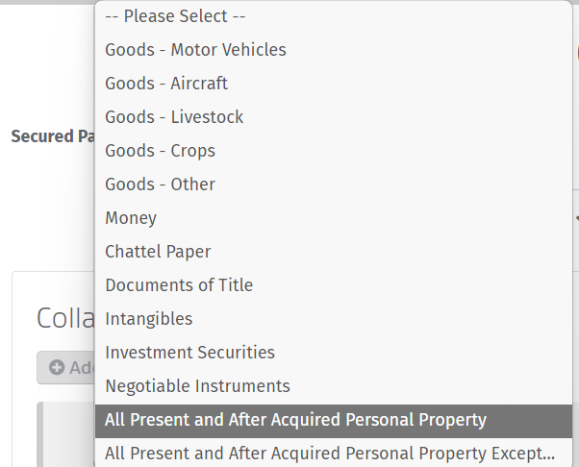

Under all Present and After Acquired personal property you can add information regarding any property you find that they own.

**All Present and After Acquired Personal Property**

I, Jane of the House of Bloggs have placed a forced commercial lien on …………………………… Corporation for the amount of ……………………………………………………………. As the Secured Party Creditor where this debt will continue to accrue ten percent interest until this debt is settled in full with lien taken over All present and after acquired property of Bay of Plenty Regional Council including the following number of properties showing current total of 31 properties where all but not limited to properties listed on publicnoticesnz.com which include 4410 GALATEA ROAD, GALATEA, MURUPARA, 3079 $450,000 2B NGAIO PLACE, EDGECUMBE, 3120 $410,000 22A STATE HIGHWAY 2, WHAKAMARAMA, 3181 $343,000 35 THE STRAND, WHAKATANE, 3120 $290,000 37 THE STRAND, WHAKATANE, 3120 $280,000 44 KEEPA ROAD, COASTLANDS, WHAKATANE, 3191 $195,000 216 PAROA ROAD, COASTLANDS, WHAKATANE, 3192 $180,000 1067 MATATA ROAD, EDGECUMBE, WHAKATANE, 3193 $127,000 16 ROBINSON AVENUE, HOLDENS BAY, ROTORUA, 3010 $100,000 51 PUKEMAPU ROAD, OROPI, 3173 $26,000 BELL ROAD, PAPAMOA BEACH, PAPAMOA, 3187 $20,000 2 AWAITI ROAD SOUTH, MATATA, WHAKATANE, 3193

$10,000 55 PATUWAI ROAD, COASTLANDS, WHAKATANE, 3191 $6,000

**Once completed Collateral – save, click next Secured Party Details**

Your details will already be here automatically

If doing lien against individual you will need DOB, address, phone contact, email often you can find this info on internet, you can do debtor search on PPSR which may give you this information, otherwise can employer a private investigator to obtain this information.

Click add debtor and fill out details all in capital letters for name, then DOB, email, phone, address then click next

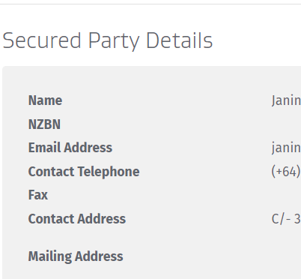

Then click Review, check all details are correct

Then click Register and will take you to payment page,

once payment made will need to click and say COMPLETE TRANSACTION

**Congratulations you have just completed your first lien!**

Reminder lien stays in place for 5 years, will need to record the lien renewal date and renew the lien if this corporation is still an issue.

**Doing a lien against an individual** is similar, but need to know DOB, then follow all the same steps as a corporation

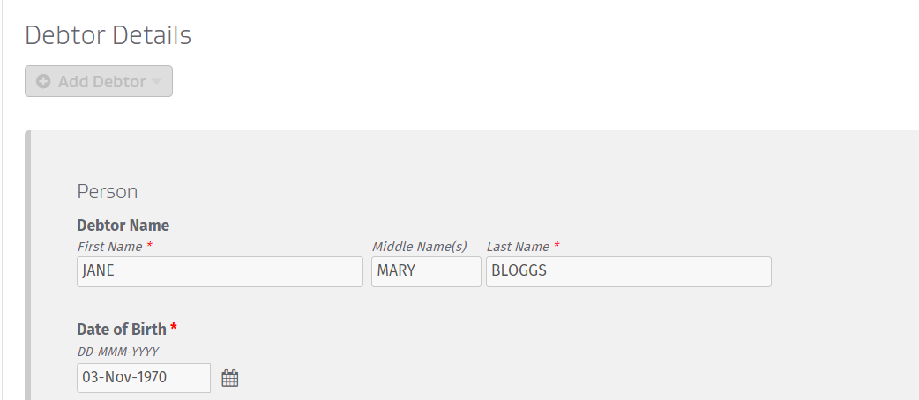

Click add collateral

