**PPSR Personal Properties Security Register**

**Go to ppsr.govt.nz**

You will need to log in first with real me, or create a login, don’t worry too much about this step, can do this as the debtor name

**Step ONE is to secure all your property**

On the screen you will see the following headings.

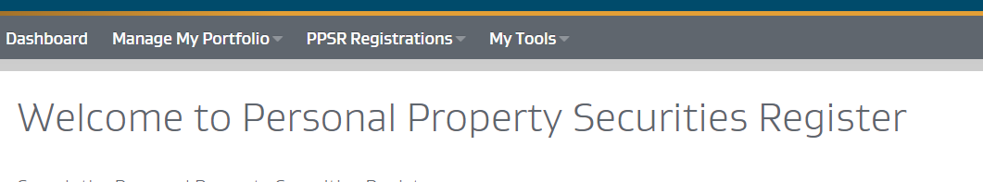

Click on manage my portfolio, then click under Secured Party Groups - Create

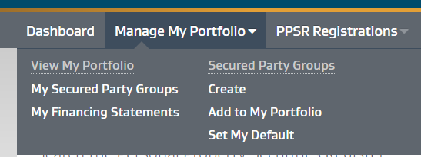

On next screen tick both boxes, then click next step

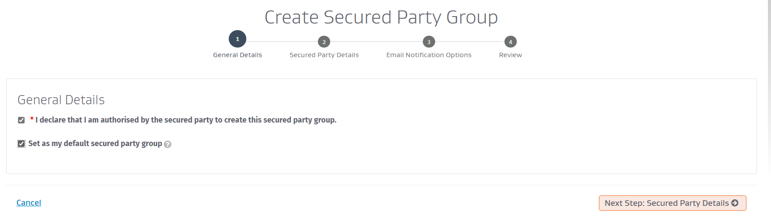

Click add Secured party, then click on person

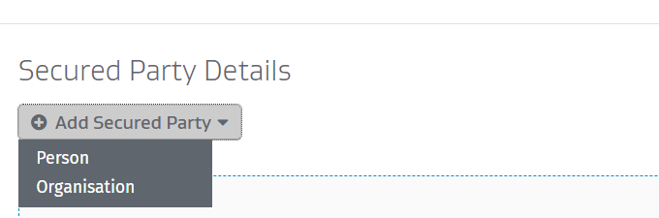

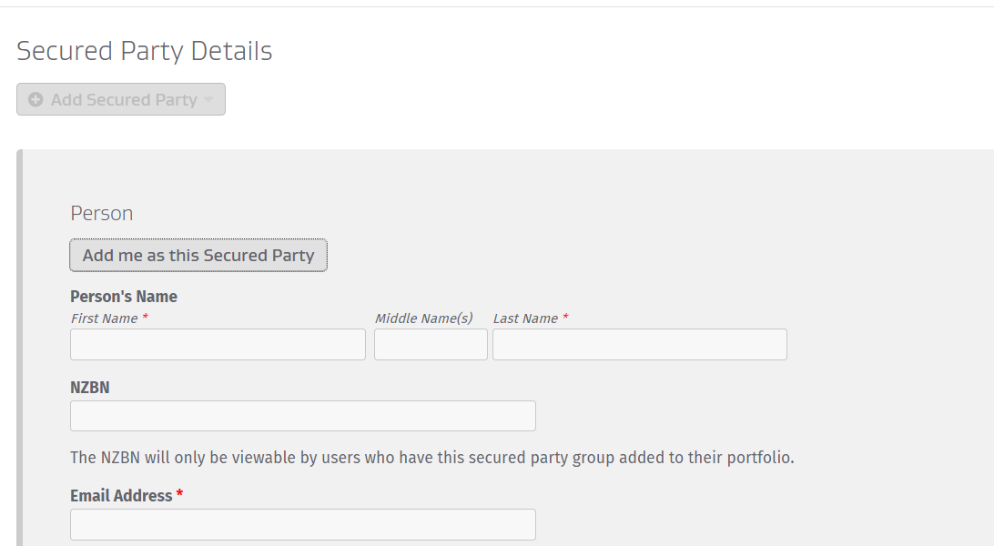

Fill out your details

For last name put … (the living do not require a surname/last name)

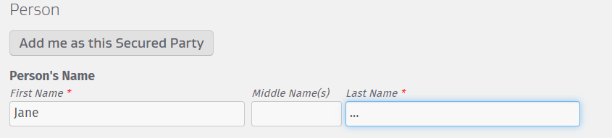

Click next, takes to page for what notifications you would like to receive by email

Tick all the boxes if you want notifications for all (recommendation)

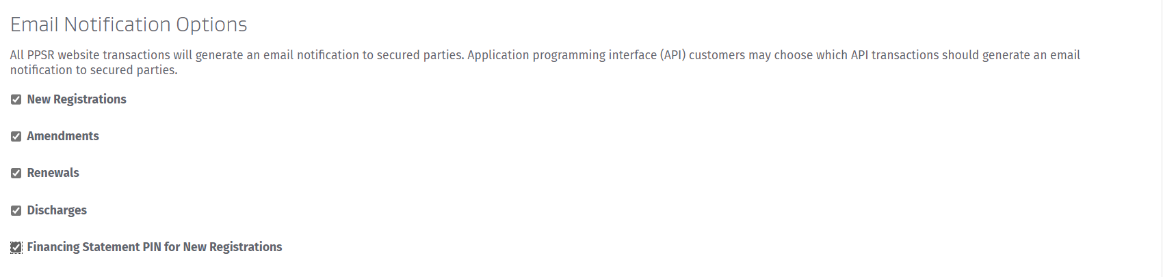

Click next, takes to review screen, check all details are correct, then click Register

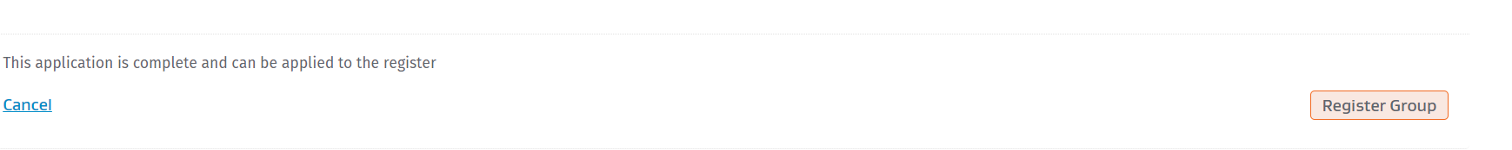

You are now set up to register financing statements.

**How to Register Finance Statement**

Log on to ppsr.govt.nz

On main dashboard screen you will see tab heading My Portfolio and under this heading you will see your secured party group, click on the ID number of your secured party group

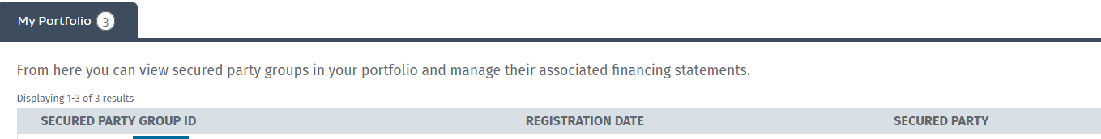

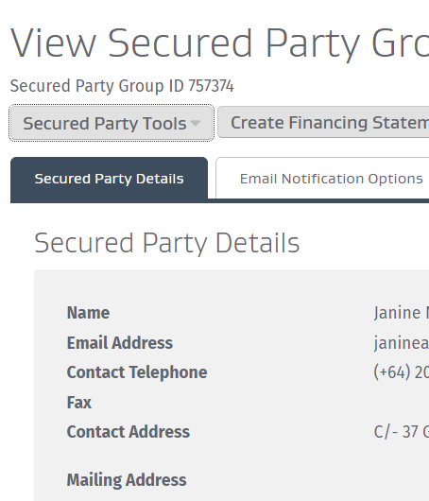

Then you will click on **create finance statement**

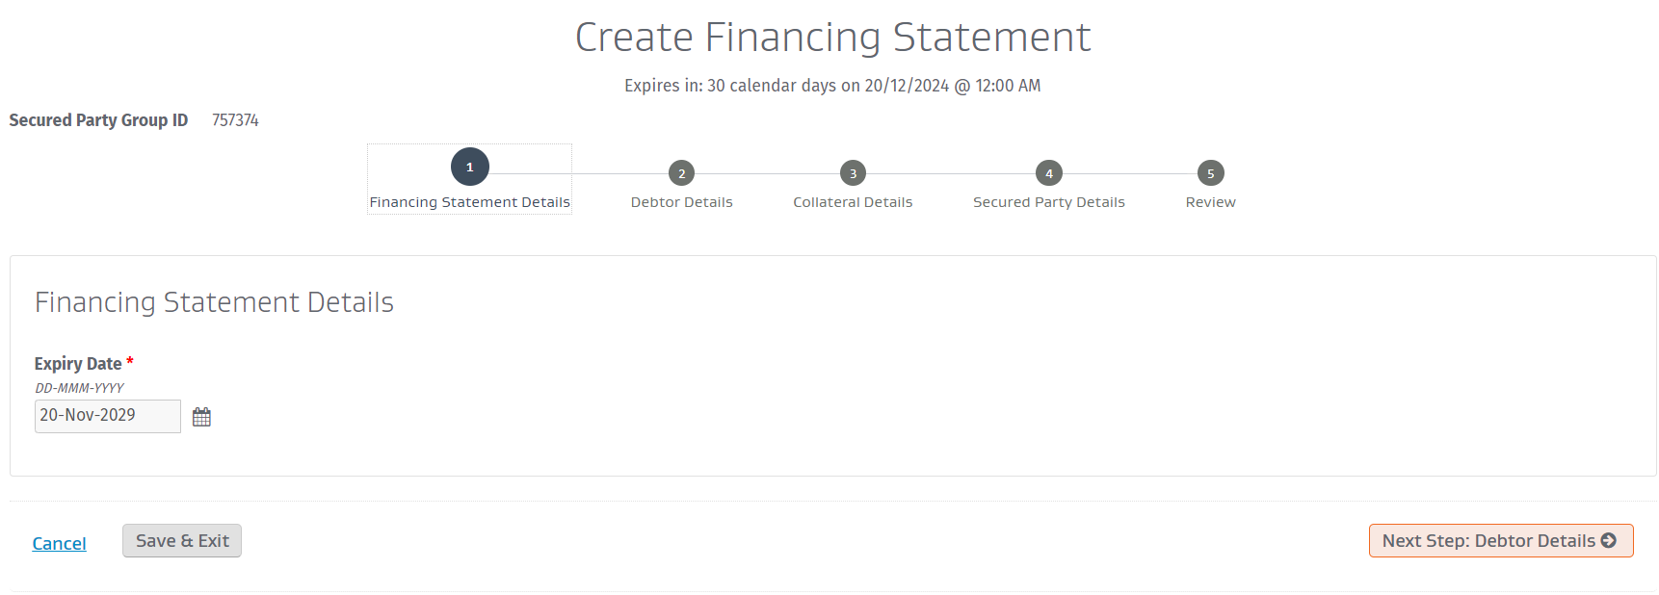

Then click on debtor details

Your first financial statement will be adding your legal trade name as the DEBTOR

Click add debtor and fill out details all in capital letters for name, then DOB, email, phone, address then click next

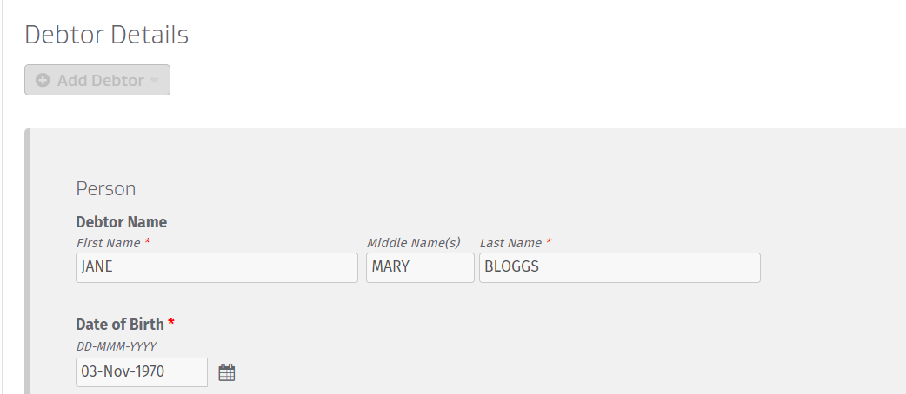

Click add collateral

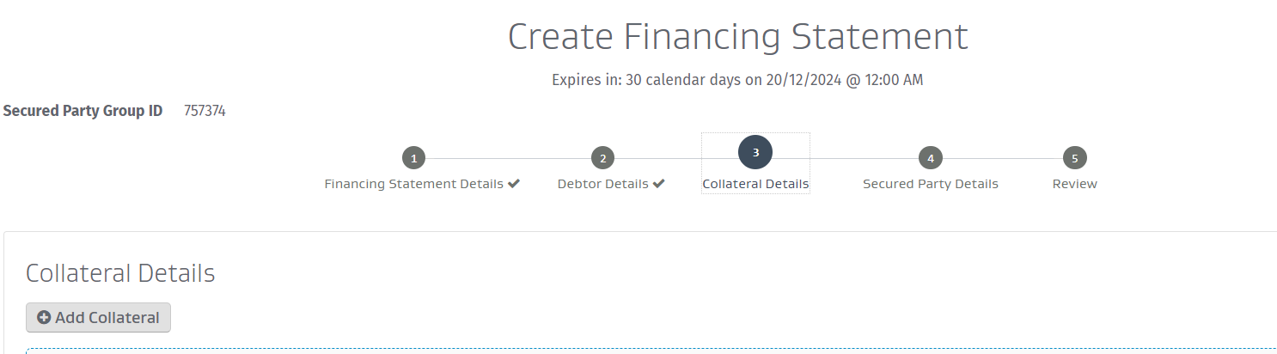

Then add collateral details for all your assets as follows where firstly you are claiming ownership over all your documents of title such as birth certificate, driver’s license, passport, bank accounts … then under **heading All Present and After Acquired Personal Property** you will list all of your properties that you are now the Secured Party Creditor of.

FINANCE STATEMENT TO COPY ONTO PPSR REGISTER

Use CTRL F to Find and replace the keys below ** use the find next NOT replace all

|  |  |
| --- | --- |
| Date | Date of agreements. Format 12th Day of June 2022 |
| Brndat | Date of birth. Format 12th Day of March 1976 |
| Lmn | Living man name e.g. John-Casey |
| B/cert | Birth certificate number |
| P/cert | Born Printout number (born certificate if you have the original |
| RG27 | RG27 form ( this may not be called RG27, use the name of the form you have that provides your born name |
| BLOGGS, JANE MARY | FULL STRAWMAN NAME |
| BLOGGS | LAST STRAWMAN NAME |
| JANE | FIRST STRAWMAN NAME |
| MARY | MIDDLE STRAWMAN NAME |
| IRD | IRD number |
| City | City or town of birth |
| FIN1 | First STRAWMAN INTIAL. E.g. J |
| FIN2 | INITIALS of STRAWMAN. E.g. J.C |
| MR/S | MR or MRS |
| SA | Security agreement number |
|  | Registered Mail number |
| MSD | MSD number |
|  | Credit Card Number |
| HHA | Hold Harmless Agreeement reference number. E.g. HH1- |
| BANK | Bank account number |
| DL | NZ Driver License |
| POA | Power of attorney document reference number. Format 20th June 2022 |

Collateral Type: Documents of Title

**Description**: Heir :Jane Mary of the House of Bloggs: born … day of ……… in year ……… (record of born entry printout RG3G P/cert ………. held at Births Deaths and Marriages, New Zealand) now of age and competent to verify as the Residuary Devisee Heir and successor with power as Secured Party of BLOGGS, JANE MARY; IRD number ……………… securitised and insured in the name of BLOGGS, JANE MARY B/cert number …………, now registers this Actual and Constructive Notice of Ancillary Claim/interest and copy right of BLOGGS, JANE MARY as the Secured Party Creditor not the debtor

Collateral Type: Documents of Title

**Description**: BIRTH CERTIFICATE: New Zealand Birth Deaths and Marriages Certificate BDM 107; BLOGGS, JANE MARY B/cert number ……………………….

Collateral Type: Documents of Title

**Description**: This is Actual and Constructive Notice of Claim held by Secured Party, Jane Mary of the House of Bloggs, and the entry of DEBTOR; BLOGGS, JANE MARY also known as SMITH JANE MARY in the PPSR Commercial Registry as a Transmitting Utility with the following property hereby registered in the same but not limited to Preferred Stock Certificate issued in the name of BLOGGS, JANE MARY IRD No. ……………… round Month/year it was listed on PPSR; with the pledge represented by same including Public and Private, predicated on the STATE and the Vessel described above as the DEBTOR, including but not limited to the pignus, hypotheca, hereditaments, res, energy and all products derived therefrom, all property, rights, interests, and claims of every kind in or to property, whether arising from, accruing under, created or evidenced by, or the subject of, an instrument, otherwise, whether liquidated, unliquidated, actual, contingent, or prospective to the sole contributing Heir and successor; Jane Mary of the House of Bloggs (Charge Holder/ Beneficiary/Creditor) securing all rights, powers (of attorney), privileges, indemnities and immunities, whether actual, contingent, prospective, muniments of title, interest in and of root of title, and every alleged birth event, document, record regarding BLOGGS, JANE MARY B/cert number ……………………….. believed to be in the possession of the Registrar of Births Deaths and Marriages New Zealand and/or New Zealand Treasury, and/or Land Information New Zealand, and all interest in the Certificate BELL, JANINE BARBARA B/cert number ……………….. all account/s receivable, debenture/s indenture/s, hereditaments, hypotheca, res, the energy and all products, proceeds, annuities, superannuation and rents derived therefrom, nunc pro tunc, including but not limited to any all names changes, ‘capitalised names’ or titles: BLOGGS, JANE MARY, SMITH, JANE MARY, MRS J SMITH, JM SMITH, MRS MARY SMITH and/or any other derivatives thereof, and, any/or agreement/s, contract/s and signature/s and/or endorsement/s, facsimile/s, printed, typed, or photocopies of “Charge Holder’s” name predicated on the name of the transmitting utility, for the equivalent sum certain value in the inherent lien of no less than TWO BILLION DOLLARS lawful currency of New Zealand ($2,000,000,000.00) and for such consideration, the living wo/man Jane Mary as Heir and successor humbly accepts the transfer.

Collateral Type: Documents of Title

**Description**: BIRTH CERTIFICATE: New Zealand Birth Certificate BLOGGS, JANE MARY B/cert number ……………………. and Whereas, the Administrators of BLOGGS, JANE MARY ANCILLARY party in PERSON (“DEBTOR”), hereby, now lawfully, actually and constructively pledge and conveys all proceeds, products, accounts, and fixtures and the orders therefrom are released to the Secured Party’s Vessel and all account information held by any State, Reserve Bank, Depository Trust Company and/or Treasury by Power of Attorney, including Irrevocable Power of Attorney given through unilateral mistake, now hereby revoked, all rights, interests, and claims of every kind in, or to property, whether arising from, accruing under, created or evidenced by, or the subject of, an instrument or otherwise, and whether liquidated or unliquidated, actual, contingent, or prospective to the residuary devisee Heir and successor to the residue Jane Mary P/cert ……. Secured Party securing all rights, powers, privileges, indemnities and immunities, whether actual, contingent, prospective, muniments of title, interest in and of the root of title, and every alleged birth event/document**/**record regarding: Printout RG3G P/cert …………. in the District of Town/city dated …… day of month in year ……… and the BDM107 Certificate BLOGGS, JANE MARY B/cert number …………………………. believed to be in the possession of the Registrar of Births Deaths and Marriages New Zealand and/or Land Information New Zealand and/or Public Trust/Trustee Company and all interest in the Certificate BLOGGS, JANE MARY B/cert number …………………………, all account/s receivable, debenture/s indenture/s, hereditaments, hypotheca, res, the energy and all products, proceeds, annuities, superannuation, and rents derived therefrom, nunc pro tunc, including but not limited to any all ‘capitalised names’ or titles: BLOGGS, JANE MARY, SMITH, JANE MARY, MRS J SMITH, JM SMITH, MRS MARY SMITH and any other derivatives thereof, and, any/or agreement/s, contract/s and signature/s and/or endorsement/s, facsimile/s, printed, typed, or photocopies of “Secured Parties” name predicated on the name of the transmitting utility, all contained in the true, certain, complete and not misleading Security Agreement SA- AOSAL-INITIALS-DMY-001, Registered Post No: ……………….., for the equivalent sum certain value in the inherent lien of no less than TWO BILLION DOLLARS lawful currency of New Zealand ($2,000,000,000.00) and for such consideration, the living man :Janine as Heir humbly accepts conveyance and transfer.

Collateral Type: Documents of Title

**Description**: BIRTH CERTIFICATE: New Zealand Birth BLOGGS, JANE MARY B/cert number ……………. And Jane, Born printout RG3G P/cert number ……………, now born again Christian as Heir and successor now prays for forgiveness as he/she forgives those who have trespassed against him/her and requires and demands every Chargeholder/Mercantile Agent/Registrar/Bailee Public Trust/Māori Trustee to convey and deliver all above property and interests that by law devolves by Will, in accord and satisfaction with our Will all accepted for value and Exempt from Levy and Duty.

**COLLATERAL**

Collateral Type: Documents of Title

SECURITY AGREEMENT: SA-AOSAL-INITIALS-DMY-001 BLOGGS JANE MARY and Jane Mary of the House of Bloggs, dated (date of affidavit of life)

Collateral Type: Insurance Policy

**Description:** Annuities BLOGGS, JANE MARY



Collateral Type: Documents of Title

**Description:** Inland Revenue Account BLOGGS JANE



Collateral Type: Documents of Title

**Description:** MSD Contract Trust account BLOGGS JANE



Collateral Type: Documents of Title

**Description:** NZL Passport BLOGGS JANE



Collateral Type: Documents of Title

**Description:** Credit card in name of BLOGGS JANE



Collateral Type: Documents of Title

**Description:** bank account of BLOGGS JANE



Collateral Type: Documents of Title

**Description:** New Zealand Drivers Licence BLOGGS JANE



Collateral Type: Chattel Paper

**Description:** Hold Harmless and Indemnity Agreement HHI- AOSAL-INITIALS-DMY-001 of BLOGGS, JANE MARY

Default Line

Collateral Type: Chattel Paper

**Description:** Power of Attorney No. POA- AOSAL-INITIALS-DMY-001 over BLOGGS, JANE MARY B/cert number ……..Default Line

Collateral Type: All present and After Acquired Personal Property

**Description:** All Present and After Acquired Personal Property of BLOGGS JANE MARY being (list all your property addresses)

Once completed click **Next step Secured Party details**

This screen shows details of you as the Secured Party**,** click **Next Step Review**

Check all the details are correct.

Then click **Register.** You will then be taken to payment page for charge of $14 plus GST. Once you have paid the finance statement will be emailed to you, but can also save and download off the screen before you log out and exit.

*Congratulations you have just secured all your personal property and assets!*

**Very important your financial statement only last 5 years so record the expiry date and ensure you renew it prior to it expiring!**