**Instructions for completing the NOTICE OF CLAIM OF LAND OF SUBSTANCE**

|  |  |  |
| --- | --- | --- |
|  |  | Your details |
| First and Middle names | e.g. Jane Emily |  |
| Family name | e.g. Bloggs/BLOGGS |  |
| Day number | e.g. 2nd or 7th or 21st etc |  |
| Day in words | e.g. fifteenth, sixth etc |  |
| Calendar month | e.g. January, April, November etc |  |
| Month number | e.g. 7th 21st 3rd etc |  |
| Man/woman | check |  |
| He/she | check |  |
| Year in words | e.g. Nineteen hundred and sixty-eight |  |
| City/town | e.g. Rotorua, Christchurch, Tauranga etc |  |
| Address – Road/Street | e.g. 128 Steephill Road, Birkenhead, Auckland |  |
| DMY | Date Month Year e.g. 16041977 |  |
| Autograph |  |  |

To use the find and replace tool on word documents

Click on home at top left then in top bar far right you will see words ‘find and replace’, click on replace, opens a window



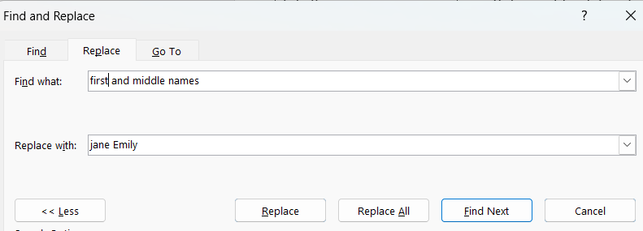

Click on box with words find and write in what you are looking for e.g First and Middle Names

Click on second box with word replace and write here your first and middle names, then click replace and check through documents one by one by clicking find next

**VERY IMPORTANT DISCLAIMER**

This document has been created to assist people who are in urgent situations who have little preparation time, however for your own learning and growth it is better to create your own one and do your own due diligence for a thorough inner/understanding. This document will continually be evaluated and tweaked. You must inner/understand what you are agreeing/stating. If you are going to use any document where you just copy the document and replace with your details it will not work if you don’t fully ‘innerstand’ what you are reading and fully believe in what you are stating. In other words if you get challenged you need to stand on what you have stated. Read this document fully to ensure you fully ‘innerstand everything before you sign it!