|  |  |  |
| --- | --- | --- |
| First and Middle names | e.g. Jane Emily |  |
| Family name | e.g. Bloggs |  |
| Day number | e.g. 2nd or 7th or 21st etc |  |
| Calendar month | e.g. January, April, November etc |  |
| Man/woman | Check and change |  |
| He/she | Check and change |  |
| Year | In numbers e.g. 1968 etc |  |
| City/town | e.g. Rotorua, Christchurch, Tauranga etc |  |
| Autograph | **Hand write your name, then place your thumb print over it** |  |

**Instructions for completing the LIVE LIFE CLAIM**



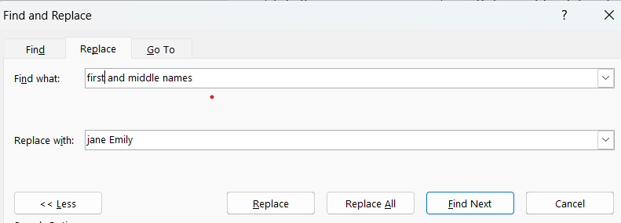

1. At the top of your word document, click on home then top right on the ‘replace’ button.
2. In the table type into the “Find what:” First and middle names
3. In the table type into the “Replace with:” your first and middle names
4. Then click “Find next” and replace accordingly throughout the entire document.
5. Repeat other ‘switch outs’ using this method
6. You may need to align the content of the document to be evenly spread out on two pages.

**VERY IMPORTANT DISCLAIMER**

This document has been created to assist people who are in urgent situations who have little preparation time, however for your own learning and growth it is better to create your own one and do your own due diligence for a thorough inner/understanding. This document will continually be evaluated and tweaked. You must inner/understand what you are agreeing/stating. If you are going to use any document where you just copy the document and replace with your details it will not work if you don’t fully ‘innerstand’ what you are reading and fully believe in what you are stating. In other words if you get challenged you need to stand on what you have stated. Read this document fully to ensure you fully ‘innerstand everything before you sign it!